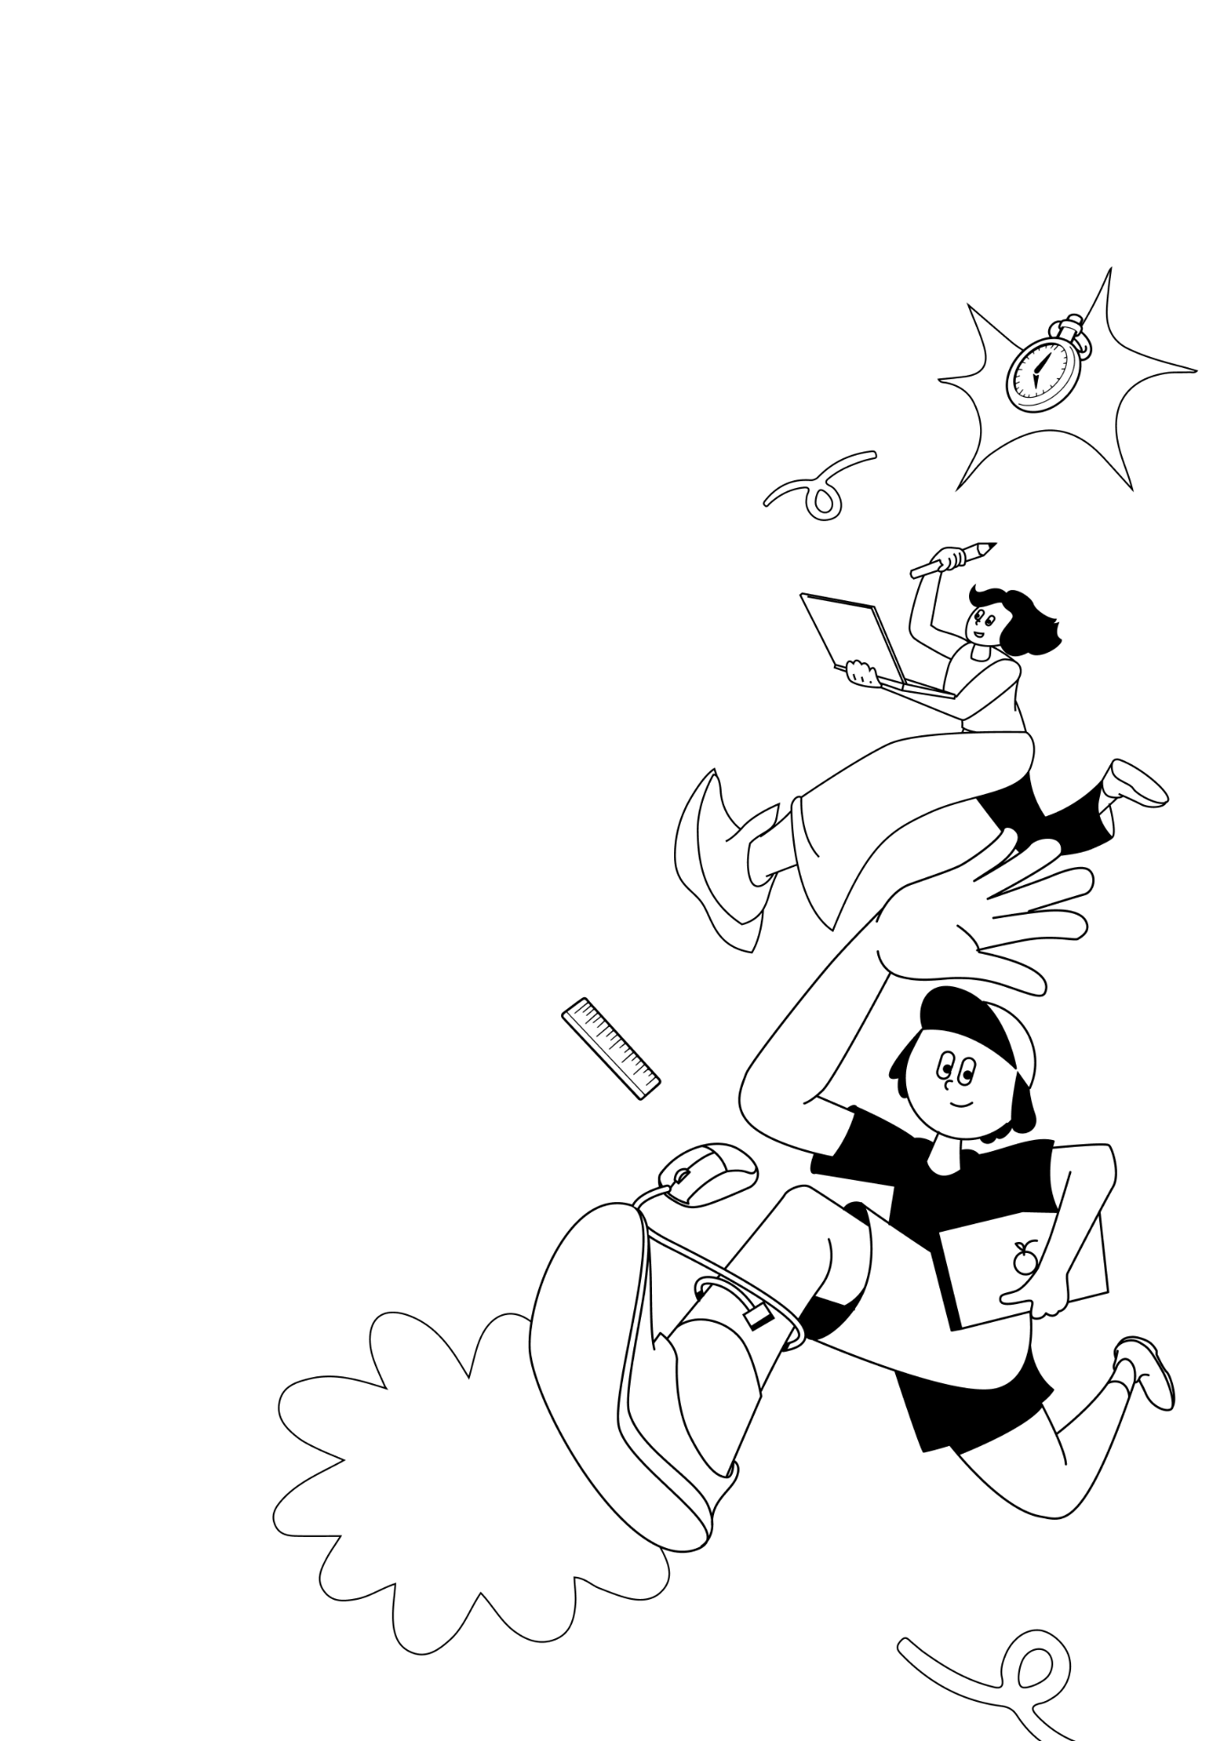
LKSN 2024

TEKNOLOGI
DESAIN GRAFIS

Module 2 (EN)
Digital Implementation
Design
LKS Nasional
AGUSTUS 2024

INSTRUCTIONS FOR COMPETITOR

- Create a folder named Competitor Number_Your Name
  - The folder must contain all final files in the format specified in the technical specification.
- You must use all the text provided in the appendix for each tasks as specified, adding or subtracting text from the appendix is ​​not allowed.
- You may use the image/photo assets that have been provided.
- You may use create raster element or additional vector provided.
- You are not permitted to use images/photos from internet or from sources other than provided.

Example of arranging folders on a Competitor’s computer:
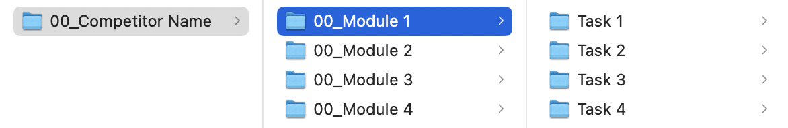

MODULE FOLDER
Module 2

PROJECT DESCRIPTION AND TASKS
This module consists of 3 (THREE) tasks that you have to do, you are not allowed to do outside the time limit that has been given.

TASK 1: LOGO MOTION

OBJECTIVE
Create a logo animation in the form of motion based on the logo that has been made from Module 1. Use animated movements that are effective and legible for small smartphone screens and are consistent with the logo identity from Module 1.

REQUIREMENT
- Logo from Module 1.

TECHNICAL SPECIFICATION
Dimension : 1080 x 1080 px (Square)
Video Codec : H.264
FPS : 30 FPS
Duration : Minimum 00:05 and maximum 00:10 seconds
Color Mode : RGB

Working File Format : AE or PSD
Final File Format : MP4
Image Format : PNG, JPG, PSD, AI, EPS, SVG

Folder Name : Competitor Number_Module 2
Sub Folder Name : Task 1
File Name : Competitor Number_Module 2_Motion Logo

YOU MUST DELIVER
Folder & file names as specified in "INSTRUCTIONS FOR COMPETITOR".
Only links & files from this folder will be marked.

1 x AE or 1 x PSD (Working File)
1 x MP4 (Final File)

TASK 2: PRINT & DIGITAL ADS

OBJECTIVE
Create Print & Digital Ads media and apply the Logo from Module 1 to fit on those medias.

REQUIREMENT
You must include:
- Minimum 2 (TWO) images.
- Logo from Module 1.
- Logo Indonesian Heritage Agency. The logo can be change to White.
- QR Code.

TECHNICAL SPECIFICATION
Dimension : 1 x A3 (297 x 420 mm - Portrait)
1 x Digital Ads (336 x 280 px - Landscape)
Image Resolution : A3 - 300 ppi
Digital Ads - 72 ppi
Color Mode : A3 - CMYK
Digital Ads - RGB
Design Element : Minimum 2 images, 3 x Logo, QR Code
Text : Module 2 Appendix 1.pdf

Working File Format : AI or PSD
Final File Format : A3 - PDF
Digital Ads - JPG
Image Format : PNG, JPG, PSD, AI, EPS, SVG

Folder Name : Competitor Number_Module 2
Sub Folder Name : Task 2
File Name : Competitor Number_Module 2_Print
Competitor Number_Module 2_Digital

YOU MUST DELIVER
Folder & file names as specified in "INSTRUCTIONS FOR COMPETITOR".
Only links & files from this folder will be marked.

2 x AI or 2 x PSD (Working File)
1 x PDF for A3 Print (Final File)
1 x JPG for Digital Ads (Final File)

TASK 3: E-TICKET

OBJECTIVE
Apply the logo and visual identity to the e-ticket using the key visual that you made in the stylescape.

REQUIREMENT
You must include:
- Logo from Module 1.
- Logo Indonesian Heritage Agency. The logo can be change to White.
- Barcode.

TECHNICAL SPECIFICATION
Dimension : 800 x 1680 px (Portrait)
Image Resolution : 72 ppi
Color Mode : RGB
Design Element : 3 x Logo, Barcode
Text : Module 2 Appendix 1.pdf

Working File Format : AI or INDD
Final File Format : JPG
Image Format : PNG, JPG, PSD, AI, EPS, SVG

Folder Name : Competitor Number_Module 2
Sub Folder Name : Task 3
File Name : Competitor Number_Module 2_E-Ticket

YOU MUST DELIVER
Folder & file names as specified in "INSTRUCTIONS FOR COMPETITOR".
Only links & files from this folder will be marked.

1 x AI or 1 x INDD (Working File)
1 x JPG (Final File)

